**Creating a simple box and making it closeable and moveable**

https://www.youtube.com/watch?v=R1vTc3v6dwo

#include "stdafx.h"

#include "SFML/Graphics.hpp"

int main()

{

sf::RenderWindow window (sf::VideoMode(600, 600), "SFML works!");

while (window.isOpen()) {

sf::Event event;

while (window.pollEvent(event)) {

switch (event.type) {

case sf::Event::Closed:

window.close();

break;

}

}

window.clear();

window.display();

}

}

**Result**

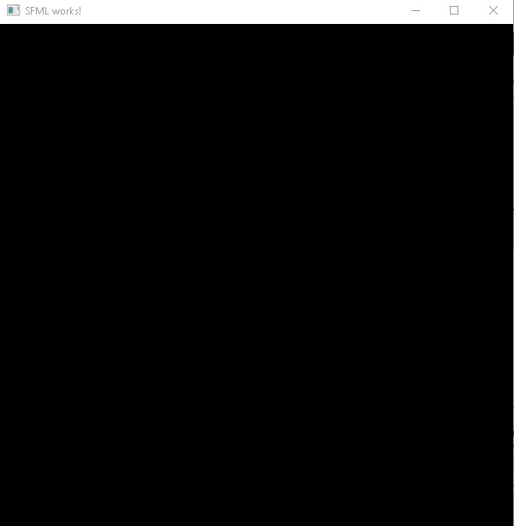

**Important points:**

* The code window.pollEvent(event) returns true when mouse makes a movement
* The code window.isOpen()will always be running as long as the program is open